RTOW Board Meeting
Monday, January 20, 2020
12:00-12:50pm

Google Hangouts format (computer and phone if possible)
Dial in at:

Phone Numbers
(US‬)+1 732-523-5179‬‬‬‬‬‬‬
PIN: 448 425#‬‬‬‬

Attendance:
 | Caitlin Maki | -- | Kelly Vlasaty | -- | Dani Mann |  | Sophia Greenheck
x | Mindy Kren | x | Tanya Nehls | x | Aaron Schroers | x | Heather Bowe
x | Melissa Norin | -- | Steve Ferin | x | Sarah Seefeld | x | Kim Steen

X = present
-- = unable to attend, contacted President prior
= no contact made prior to meeting
Agenda:

- Welcome
  - Tanya and Aaron as north reps
  - Kelly as our new Treasurer
  - Reports
- Reports:
  - Treasurer
    - Any issues with transition
    - Payments coming in okay
    - Cannot attend April 4th meeting, audit is due:
      - any volunteers to meet for a 30-45 minute meeting in Wausau on a Saturday? Kelly is willing to go to Wausau.
        - Aaron willing to; will need to check on dates and times
  - Secretary
    - Registration/Renewals coming in okay
      - A couple emails came in with issues, Mindy thinks she fixed them, please let her know if we hear any more issues popping up
      - Student Membership was changed a bit; added in administrative approval to verify that these are truly students; website wording will tell the students that approval is pending
        - Changes will be seen in Fall of 2020
      - Board member renewals:
        - Board members must still renew each year and then if want reimbursement then can submit a request. This year Mindy will renew board members if they want without having to pay and then get reimbursed. She will reach out to those still needing to renew.
  - Webmaster
    - Kelly and Heather tag teamed the transition to Wild Apricot new payment option
    - Updated By-laws are posted
    - Need to update the board members, Kim will re-send out the email
- Lottery/Grant Registrations
    - Heather and Mindy work on figuring out how to get that set up on website
    - Once active then we will keep up for 30 days and then do the drawing after 30 days

- By Law Changes: Board Member Requirements-Address in the bylaws?
Issue: This is not always being adhered and should we tweak the wording to allow for more leniency, to be that of 50% of offered meetings or 75%?

Bylaws state:

The duties of the Officers shall be as follows:
- ALL: Voting and Non-voting board members shall attend all executive board meetings. If unavailable to attend, board member must inform President and pass along all updates.

- Therapist Scholarship-non RT students
  - Anyone know of any therapists looking to apply? Paper is due on January 31 to the RTOW president.
  - SO far no one has turned anything in.
- Spring Meeting
  - Partnership with Aspirus
  - Saturday, April 4, 7:45-4:30; 8 Credits
  - RTOW Lunch Meeting will be on its own in separate meeting room, cost of lunch is part of registration to Aspirus.
  - All revenue will go to Aspirus
  - All RTOW members/students will register via Aspirus registration but make mention that as RTOW for head count for lunch.
  - Kim will check with Rhonda (Aspirus) as to best way to get the students registered for lesser payment
    - RTOW will pay the difference in cost, however should it be upfront or have each student submit a reimbursement request.
  - Kim will find hotel for block of rooms for Friday evening (all attendees) and for Board Meeting, April 3
    - Might be in Stevens Point as there is a lot going on in Wausau that weekend.
  - Up for Nomination
    - South West
    - South East
    - Secretary

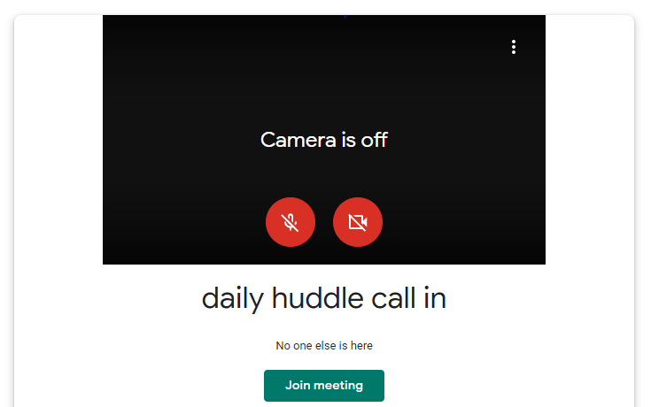
To Access the computer piece, click on link in calendar invite:
- Then deactivate the microphone and camera by clicking on those icons and turn them red
- Then click on Join Meeting
- Dial the phone number and pin posted above to call into
meeting.

