Frameless Stereotactic Radiosurgery Amongst Gamma Knife and Linear Accelerator Based Systems

Abstract
Background: Traditionally SRS has been performed using a fixated head frame attached to the patient’s skull and the treatment table. This has proved to give great treatment accuracy but also has many downsides, such as patient discomfort, increased patient anxiety, and the chance of a frame slip. Recent developments within the past decade have allowed patients to be treated with a frameless modality involving a thermoplastic mask and a motion management system. Both Gamma Knife and linear accelerator modalities are available, and this review was conducted to evaluate similarities and differences among them.
Objectives: The objective of this review is to evaluate Gamma Knife and linear accelerator frameless SRS systems. Topics evaluated include patient accessibility, treatment time, dosage, motion management systems, treatment beam sources, and more.
Methods: A literature review was conducted primarily using PubMed and the Ebling Library databases. A handful of reliable articles and research papers were found and evaluated for data.
Results: Both Gamma Knife and linear accelerator systems produce excellent treatment outcomes. Treatment times, increased cost, and patient accessibility varies among the treatment modalities.
Conclusion: Linear accelerators provide additional benefits when treating with frameless SRS. Patients generally have easier access to treatment facilities with linear accelerators, treatment times are decreased, and cost of operation is decreased. Both systems provide great outcomes for the patients, but linear accelerators currently provide more benefits.

Introduction
Stereotactic radiosurgery (SRS) is a type of external beam radiation therapy that has the capabilities to deliver large doses of radiation to small tumors with high precision.¹ The basis for SRS was conceived by Lars Leksell, who proposed the idea of focusing multiple nonparallel beams at the same defined intracranial target.² Using this technique, the intersecting beams deposit very high doses of radiation to the target volume, while sparing nontarget tissues along the path of any given beam.² Due to the need for these beams to be highly accurate, SRS requires small margins, special planning techniques, and dedicated equipment to achieve this high conformity.¹ Stereotactic radiosurgery is primarily used to treat brain lesions and it can be delivered in a few different ways.¹ Historically, patients receiving SRS for brain lesions had a frame fixated to their head using sharp pins against the skull.¹ With this system, the location of the target can be identified in relation to the frame, these frames also played a role in both immobilization and positioning while reporting accuracy within 1 mm of the treated lesion.¹ Although the frames were effective, they also increased patient anxiety, there was pain associated with the frame fixation, and had an increased risk of bleeding and infection at the site of placement.¹
With the advances of image guidance technology coupled with improving treatment modalities, there has been a transition to frameless SRS techniques.¹ Instead of the fixated frame, non-invasive immobilizers are used, such as thermoplastic masks.¹ With the use of a thermoplastic mask, along with image guided tumor localization techniques and intrafraction monitoring, these methods are comparable to the traditional framed technique, with added benefits.¹ Both the Gamma Knife system and linear accelerator system can currently administer treatment using frameless SRS. ³ The linear accelerator system was created as an alternative to Gamma Knife in the 1980s, proving to have similar precision, accuracy, and stability.³ Today, any treatment facility capable of treating patients with frameless SRS will be equipped with either a Gamma Knife or linear accelerator system, operated most by radiation therapists, radiation oncologists, and physicists.³ The objective of this review is to analyze similarities and differences amongst the Gamma Knife and linear accelerator systems and how they both effectively treat with frameless SRS.
Methods
A literature review was conducted to assess the current knowledge about frameless SRS amongst Gamma Knife and Linac based systems. PubMed and the Ebling Library database were the primary databases used for this search. The following terms were used in combination to find the articles used in this literature review: “stereotactic radiosurgery”, “SRS”, “framed”, “frameless”, “Gamma Knife”, “linear accelerator”, “linac”, “radiation therapy”, “stereotactic”, “side effects”, “toxicities”. The search was then confined to articles written within the past five years, peer reviews, and that were published in English. The articles were examined and chosen if they were deemed reliable, unbiased, and contributed valuable information to this review. The articles included are relevant to treatment processes for linear accelerators and Gamma Knife frameless SRS treatments.
Review of Literature
Stereotactic radiosurgery is becoming a more commonly used treatment modality for brain tumors and other brain disorders that can’t be treated with surgery, external beam radiation therapy, or other treatment modalities.¹ Radiation therapists are the primary technicians that deliver these treatments and are being trained on linear accelerator and Gamma Knife systems. It is important for practicing radiation therapists to be well acquainted with the treatment process for each modality starting from computed tomography (CT) simulation, treatment planning, treatment delivery, and follow up care for these patients. There are also many benefits of being acquainted with different treatment modalities, and how different treatment processes produce the same result for these patients. Having a good understanding of this treatment technique can improve knowledge and awareness of the benefits of frameless SRS amongst both linear accelerator and Gamma Knife systems.
Simulation and treatment process
Before patients can receive frameless SRS on a linear accelerator, they must undergo a CT simulation planning session. This planning session involves making a thermoplastic mask that will be used for treatment.⁴ The CT simulation process for frameless SRS is similar to that of any patient undergoing conventional external beam radiation therapy treatment. Prior to the patient’s arrival, radiation therapists will prep 120 ml of contrast (typically Omnipaque or Visipaque) and place the thermoplastic mask in a water bath heated at 120 degrees Fahrenheit. The brand/type of thermoplastic mask used varies amongst treatment facilities and all produce similar results. Radiation therapists will ensure informed consent has been signed and confirm with the patient the area of the body being treated, if they have a pacemaker, and if they have had previous radiation therapy. These questions will be important for the treatment planning aspect completed by physics and dosimetry.
For Linac based SRS, the patient will lie on the treatment table headfirst supine on a QFix stereo S-frame board.⁴ The mask will attach to the SRS treatment board which is attached to the treatment table. The SRS masks have an opening over the patient’s nose and eyebrows to provide reference points for the motion management system to track during treatment (See Figure 1).⁵ It is important to conform the mask 2 cm above the brow line, just below the nose, and at least to the hairline in front of the ears on both sides, as this gives the motion management system a proper area to monitor during treatment.⁴ Radiation therapists must wait six minutes after the contrast is administered intravenously to obtain their CT scan, to ensure the contrast has penetrated the blood brain barrier and reached the areas in the brain that is targeted.⁴ On the day of treatment, the patient is immobilized with the same thermoplastic mask and another CT scan is taken to verify proper alignment.⁵
Treatment planning for Gamma Knife SRS is a bit different from the linear accelerator system. For Gamma Knife SRS, patients will first acquire an MRI on the day of their treatment.⁶ From this MRI, the radiation oncologist will make the plan and delineate the targets.⁶ Next the patient will enter the Gamma Knife Icon suite and be positioned headfirst supine onto the table where they are instructed to lie down as far up the couch in the Y axis as possible.⁶ A similar thermoplastic mask will then be formed, however for Gamma Knife SRS, the mask will cover the patient’s entire face, with the exception of their nose (See Figure 2).⁶⁻⁷ The nose must be left open as Gamma Knife systems use a tracker placed on the patient’s nose to detect patient movement during treatment.⁷
Once the mask is made, a reflective marker is placed on the patient’s nose to provide reference points on images for the treatment plan.⁷ The radiation therapists will obtain a CBCT (cone-beam computed tomography) with the patient in treatment position and it is registered with the planning MRI.⁶ After the registration is complete, the dose distribution is calculated, and modifications are made to the plan if necessary.⁶ Once completed, the radiation therapists will obtain a second CBCT to ensure there was not patient movement during the time lapse.⁶ The motion management system is then engaged and tracks the motion of the nasal tip during treatment.⁶ If there is deviation beyond the threshold the radiation beam will turn off until modifications are made.⁶⁻⁸ The Gamma Knife Icon has the threshold setting default to 1.5 mm tolerance; however, it will allow manual changes to the threshold up to a 3 mm tolerance.⁸ Once the set up and treatment planning process is complete, treatment will begin and can last between 15 minutes to one hour.⁷
Linac based systems
Linear accelerator-based systems utilize highly energetic photons that are produced electronically to treat patients.² One of the most common linear accelerator-based systems for treating frameless SRS is the Varian Edge.⁹ The Varian Edge has extra-fine 2.5 mm multi-leaf collimators (MLC), high dose rate (flattening filter free), six degrees of freedom couch, and much more.⁹ These features and its ability to track tumor position in real time via optical surface monitoring system (OSMS) make it a great candidate for delivering frameless SRS.⁹ With this modality, treatment can be delivered via 3D conformal radiation therapy (3D-CRT), dynamic conformal arc therapy (DCAT), or intensity-modulated radiosurgery (IMRS).¹ Intensity modulated radiosurgery uses several static fields with non-uniform radiation dose to produce complex dose distributions.¹
Linear accelerator SRS may be delivered using either circular cones or micro-multileaf collimators (mMLC) attached to the head of the linear accelerator.¹ Circular cones are typically used for treating small, spherical lesions.¹ By using the cones (most commonly 10 or 15 mm sizes), multiple non-coplanar arcs are formed for a spherical dose distribution.¹ The cones attach to the gantry and therefore are closer to the patient, resulting in a sharper penumbra.¹⁰ The disadvantage of using cones include having a higher chance of collision due to the decreased distance to the patient, clearance issues, and increased treatment time.¹⁰ On the other hand, a mMLC technique produces a better dose conformity and reduces treatment times.¹ The MLC leaves can move individually to create a field size that fits the target shape.¹ These smaller MLCs allow excellent target coverage without any hot spots and decreases dose to normal tissues.¹
Gamma Knife based systems
The Gamma Knife Icon is a stereotactic radiosurgery machine that utilizes a live cobalt-based source.¹¹ It was specifically designed to improve versatility by creating a mask-based immobilization system for frameless SRS, while still having the option to treat SRS with the traditional fixated frame.¹¹ Along with the mask-based immobilization system, the Gamma Knife Icon comes equipped with a cone beam computed tomography (CBCT) and intrafraction motion management system.¹¹ The CBCT is calibrated and attached to the unit, which eliminates the use of fiducial markers.¹¹ Fiducial markers were used in the previous Gamma Knife models as the primary modality for motion management during treatment. The intrafraction motion management system uses an infrared camera and a reflective marker that is placed on the patient’s nose.¹¹ A threshold is set (typically 1.5mm window) and if the movement of the marker is outside the threshold, treatment will be held until adjustments have been made.¹¹
A study¹¹ done at Mayo Clinic in Jacksonville FL, evaluated data from 124 patients (358 intracranial tumors) who were treated for frameless SRS via the Gamma Knife Icon. Age and gender were well mixed along with the type of tumors and histology being treated.¹¹ Each patient received treatment and 87 percent of patients received at least one MRI post treatment to monitor their response.¹¹ One hundred percent of primary brain tumors maintained stable disease or achieved a partial response.¹¹ Ninety one percent of patients being treated for brain metastases maintained local control, while 21 percent required additional treatment due to intracranial metastases elsewhere.¹¹ Along with tumor response, this study also investigated how the Gamma Knife Icon’s frameless system compared to the traditional fixated frame.¹¹ They found that the CBCT (used in the frameless system) was more accurate than traditional fiducial markers (used in the framed system).¹¹ Similarly, the intrafraction motion management system was shown to detect submillimeter displacements.¹¹
Comparison of the systems
Data shows that both Linear Accelerator and Gamma Knife based frameless SRS provide exceptional outcomes for treating intracranial brain tumors. If they yield similar results, then how is it determined which treatment modality best fits each patient? A study¹² done by McClelland et al. examined which factors played a role in determining the treatment modality patients received. This study looked at over 4,000 patients who had received frameless SRS for brain metastases from non-small cell lung cancer. ¹² The study used the National Cancer Database (NCDB) to evaluate radiation dosage, technique, and target for patients receiving frameless SRS.¹² Of the participants, 60 percent received Gamma Knife SRS while forty percent received Linac SRS.¹² Although more participants received Gamma Knife SRS, the analysis revealed that patients with increased age, higher income, more education, and patients living within a close proximity to the treatment facility (within 20 miles) were associated with an increased likelihood of receiving Linac SRS.^{3,12} Similarly, larger urban centers, non-academic facilities, and certain geographic regions (Northwest, Midwest, and Southern United States) were more likely to use Linac based SRS.^{3,12}
Dosage is a large factor in determining which treatment modality is best suited for the patient.¹² Tumors being treated to higher dosage were strongly associated with using Linac SRS.¹² Dose recommendations from the RTOG 90-05 (SRS protocol) state brain tumor lesions sized 0-2 cm should receive a dose of 24 Gy, lesions 2.1-3 cm should receive 18 Gy and lesions 3.1-4 cm should receive 15 Gy.¹² This indicates that smaller tumors (less than 2 cm) were more likely to be treated on a Linac system.¹² Additionally, the use of a Linac for frameless SRS comes with additional benefits including decreased cost and easier maintenance.³ The Cobalt source in Gamma Knife systems brings with it some added difficulties - such as the regular cost of replacing the decaying Cobalt source.³ There are also tight regulations in place from the Nuclear Regulatory Commission (NRC) due to the live Cobalt source – including the required presence of a radiation oncologist during the entire procedure.³ Due to this increased cost Gamma Knife installation is more common at large academic centers or private centers.³
Since both linear accelerator SRS and Gamma Knife SRS deliver high doses to small volumes, they must have motion management systems monitoring patient motion to avoid inaccurate dosage to nearby structures.¹³ The optical surface monitoring system (also known as AlignRT) is used by linear accelerator systems and uses three ceiling-mounted camera pods that capture the skin surface in real time and can detect motion in all six degrees of freedom (lateral, longitudinal, vertical, pitch, roll, and yaw).¹³ Predetermined windows, or limits, are set prior to treatment. If the patient moves outside of the window, the radiation beam will be held until the patient’s position comes back within the limit.¹³ The Gamma Knife Icon uses a real-time tracking system known as high definition motion management (HDMM) to monitor the patient throughout treatment by using a reflective marker placed on the patient’s nose.¹³ When treatment begins a CBCT is taken and a baseline position of the patient marker is established.¹³ From there, the system tracks the position of the marker relative to its baseline.¹³ Similar to OSMS, if the marker moves outside of the baseline, treatment will be held until the deviations are corrected.¹³
Accuracy of intrafraction motion is essential, which is why any frameless SRS modality must use some format of motion management during treatment. A study¹³ was conducted using a 3D printer-based cranial motion phantom to evaluate the accuracy and sensitivity of OSMS and HDMM. The results showed that both techniques had submillimeter accuracy in detecting displacement alone the X and Z directions.¹³ Optical surface monitoring system did show different results when using different areas as the reference ROI – with greater accuracy when using the central face and nose compared to the forehead.¹³ As for speed, both systems were able to detect motion changes within 20-30 mm/s.¹³ Overall, the results showed that both motion management systems were able to detect changes quickly and in all directions, making them accurate tools to use for frameless SRS.¹³
Treatment time is also an important factor when comparing linear accelerator and Gamma Knife systems.¹⁴ Linear accelerator systems can use flattening filter free (FFF) beams which decrease treatment times.¹⁴ A study¹⁴ that compared outcomes from different clinical trials focusing on radiation therapy for multiple brain metastases found that with the use of FFF beams a linear accelerator could treat three brain metastases in approximately six minutes, compared to 45-50 minutes on a Gamma Knife machine. Another benefit of a linear accelerator system is that multiple brain metastases can be treated simultaneously on a linear accelerator.¹⁴ Decreasing treatment time is largely beneficial, as the more time it takes for treatment, the higher the risk of patient movement and positioning errors.¹⁴
Follow up and evaluation of possible toxicities are very important for these patients. Patients being treated will typically have a follow up MRI every two to three months following their procedure. ⁶ A study conducted by Vulpe et al. ⁶ followed 100 patients who had received Gamma Knife frameless SRS. Of these 100 patients 16 local recurrences were identified in nine patients with metastases and seven patients with high-grade gliomas. ⁶ The average time frame between treatment and recurrence was 120 days. ⁶ A study done by Minniti et al.¹⁵ evaluated toxicities and outcomes of 40 patients who received frameless SRS on a linear accelerator for brain metastases. For these patients, the average follow up time was 10.8 months, one year survival was 65 percent, and local control rates were 86 percent.¹⁵ Common acute toxicities from SRS include fatigue, alopecia, and radiation dermatitis.¹⁶ Determining late toxicities of SRS is difficult due to the short life expectancy of the patients receiving SRS.¹⁶
Conclusion
In conclusion, both linear accelerator and Gamma Knife systems are effective for treating brain lesions with frameless SRS. Gamma Knife was the first modality available for treating brain lesions with frameless SRS and it uses a live Cobalt source for its treatment beam.¹¹ Linear accelerators use high energy photon beams and have primarily been used for external beam radiation therapy.² With new developments linear accelerators are now also being used as a treatment modality for frameless SRS and bring with it many advantages.² The studies(citation) that have been evaluated have shown that linear accelerators are providing added benefits for hospitals and patients when used for frameless SRS, more so than Gamma Knife.³ Due to the increased accessibility of linear accelerators, patients are more likely to live closer to a facility with a linear accelerator than a gamma knife.³ Linear accelerators are also associated with lower expenses of operation, easier to use, decreased treatment times, and submillimeter treatment accuracy.³ Gamma Knife systems will produce the same submillimeter treatment accuracy, submillimeter motion management tracking, and treatment outcomes as linear accelerators, but come with the added difficulties of having a decaying Cobalt source and increased treatment times.¹¹
There is a shortage of research available that has evaluated long term outcomes of patients treated with frameless SRS on linear accelerators versus Gamma Knife systems. A comprehensive review of long-term outcomes and toxicities would be greatly beneficial for treatment facilities and patients to evaluate which treatment modality would best fit their needs. Overall, the evolution of framed SRS to frameless has drastically increased the quality of these treatments for patients. Nevertheless, SRS can be a frightening procedure for patients, and it is important to be knowledgeable about the technology being used. Having a better understanding of different treatment systems will be largely beneficial for healthcare professionals participating in cancer care.

Figure 1. A Thermoplastic Face Mask Used for Linear Accelerator Based Stereotactic Radiosurgery
The thermoplastic mask is formed during CT simulation and is precisely conformed to patient’s face. The mask is attached to the treatment table during treatment to ensure proper immobilization for the patient. Figure courtesy of University of Wisconsin Hospital and Clinics.⁵
Figure 2. A Thermoplastic Face Mask Used on the Gamma Knife Icon for Frameless Stereotactic Radiosurgery
Prior to treatment the radiation therapists will make the thermoplastic face mask for immobilization during treatment. They carefully fold bask the rim around the nose to avoid sharp edges and apply pressure over the chin and forehead to keep the mask properly formed to the patients face. ⁶ Figure courtesy of Sentara Martha Jefferson Hospital.¹⁷

Figure 1.
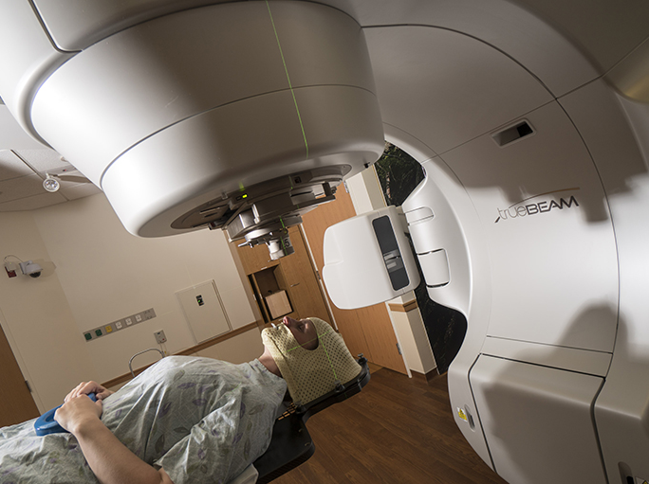
Figure 2.
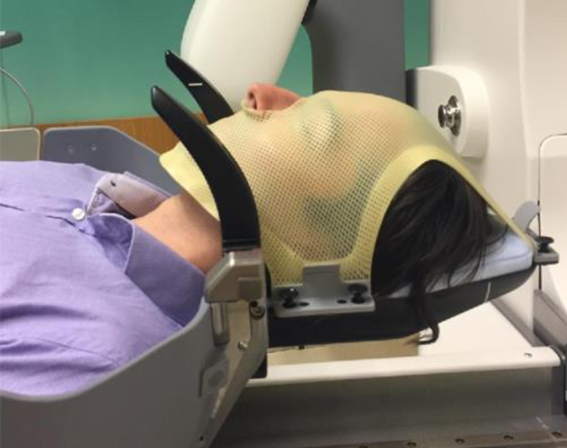

References
- Hanna S, Mancini A, Dal Col, et al. Frameless image-guided radiosurgery for multiple brain metastasis using VMAT: A review and an institutional experience. Frontiers in Oncology. 2019;9:703. doi:10.3389/fonc.2019.00703

- Friedman W, Bova F. Linear accelerator-based radiosurgery: Technique. In: Trifiletti D, Chao S, Sahgal A, et al., ed. Stereotactic Radiosurgery and Stereotactic Body Radiation Therapy. Springer, Cham. Published June 28, 2019. doi: 10.1007/978-3-030-16924-4_7

- Park HS, Wang EH, Rutter CE, et al. Changing practice patterns of Gamma Knife versus linear accelerator-based stereotactic radiosurgery for brain metastases in the US. Journal of Neurosurgery. 2016;124(4):1018-1024. doi:10.3171/2015.4.JNS1573

- Labby Z. Open-Face Mask Simulation. University of Wisconsin Hospitals and Clinics. Reviewed on July 10, 2018. Accessed on February 24, 2021.

- New frameless stereotactic radiosurgery technique improves patient experience. Department of Human Oncology – University of Wisconsin School of Medicine and Public Health. https://www.humonc.wisc.edu/new-frameless-stereotactic-radiosurgery-technique-improves-patient-experience/. Accessed February 24, 2021.

- Vulpe H, Save A, Xu Y, et al. Frameless stereotactic radiosurgery on the gamma knife icon: Early experience from 100 patients. Neurosurgery. 2020;86(4): 509-516. doi: 10.1093/neuros/nyz227

- Mayfield Clinic. Gamma Knife Stereotactic Radiosurgery (frameless mask). Mayfield Clinic website. https://www.mayfieldclinic.com/pe-gammamask.htm. April 2018. Accessed February 20, 2021.

- Wright G, Schasfoort J, Harrold N, et al. Intra-fraction motion gating during frameless Gamma Knife Icon therapy: The relationship between cone beam CT assessed intracranial anatomy displacement and infrared-tracked nose marker displacement. Journal of Radiosurgery and SBRT. 2019;6(1): 67-76. PMCID: PMC6355448

- Edge. Varian. https://www.varian.com/products/radiosurgery/treatment-delivery/edge. Accessed February 24, 2021.

- Padilla L, Palta JR. Overview of technologies for SRS and SBRT delivery. Radiology Key. https://radiologykey.com/overview-of-technologies-for-srs-and-sbrt-delivery-2/. April 30, 2020. Accessed February 20, 2021.

- Bush A, Vallow L, Ruiz-Garcia H, et al. Mask-based immobilization in gamma knife stereotactic radiosurgery. Journal of Clinical Neuroscience. 2021;83:37-42. doi:10.1016/j.jocn.2020.11.033

- McClelland S, Degnin C, Chen Y, et al. Predictors of linear accelerator versus gamma knife stereotactic radiosurgery use for brain metastases in the United States. Journal of Radiosurgery and SBRT. 2020;6(4):263-267. PMCID: PMC7065892

- Wang H, Xu Z, Grantham K, et al. Performance assessment of two motion management systems for frameless stereotactic radiosurgery. Strahlentherapie Onkologie. 2020;10.1007. doi:10.1007/s00066-020-01688-8

- Hartgerink D, Swinnen A, Roberge D, et al. Linac based stereotactic radiosurgery for multiple brain metastases: Guidance for clinical implementation. Acta Oncologica. 2019;58(9): 1275-1282. doi: 10.1080/0284186X.2019.1633016

- Minniti G, Capone L, Nardiello B, et al. Neurological outcome and memory performance in patients with 10 or more brain metastases treated with frameless linear accelerator (LINAC)-based stereotactic radiosurgery. Journal of Neuro-Oncology. 2020;148(1): 47-55. doi: 10.1007/s11060-020-03442-7

- Fetcko K, Lukas RV, Watson GA, et al. Survival and complications of stereotactic radiosurgery. Medicine. 2017;96(42): e8293. doi: 10.1097/MD.0000000000008293

- Crimaldi A. SRS: A significant step forward in treating brain metastases. https://sentaramarthajeffersonclinicalfront.yourwebedition.com/stories/srs-a-significant-step-forward-in-treating-brain-metastases. Spring 2017. Accessed February 20, 2021.

